Programming in GIS I

Practical 2

Name: NIKAM PRITI RAJU

Course: MSC.GEOINFORMATICS

RollNo. 05

# Practical 2: Variables and Data Types

Q1. What is the difference between a Variable and a Constant?

|  |  |
| --- | --- |
| Variable | Constant |
| Variable: A variable is a named container for storing data. | Constant (const):A constant is also a named container for data, but its value cannot be changed after it's assigned (i.e., they are immutable) |
| Variables can have their values changed (i.e., they are mutable). Variables declared with var and let can have their values reassigned. | You declare a constant using the const keyword. |
| You declare a variable using the var, let, or const keyword. | Constants are typically used for values that should not be modified during the program's execution. |
| Example:  let x = 5;  x = 10; // You can change the value of x | Example: const pi = 3.14159;  // You cannot change the value of pi:  pi = 3; // This will result in an error |

Q2. Create a JavaScript program to assign a string value to a variable and print it.

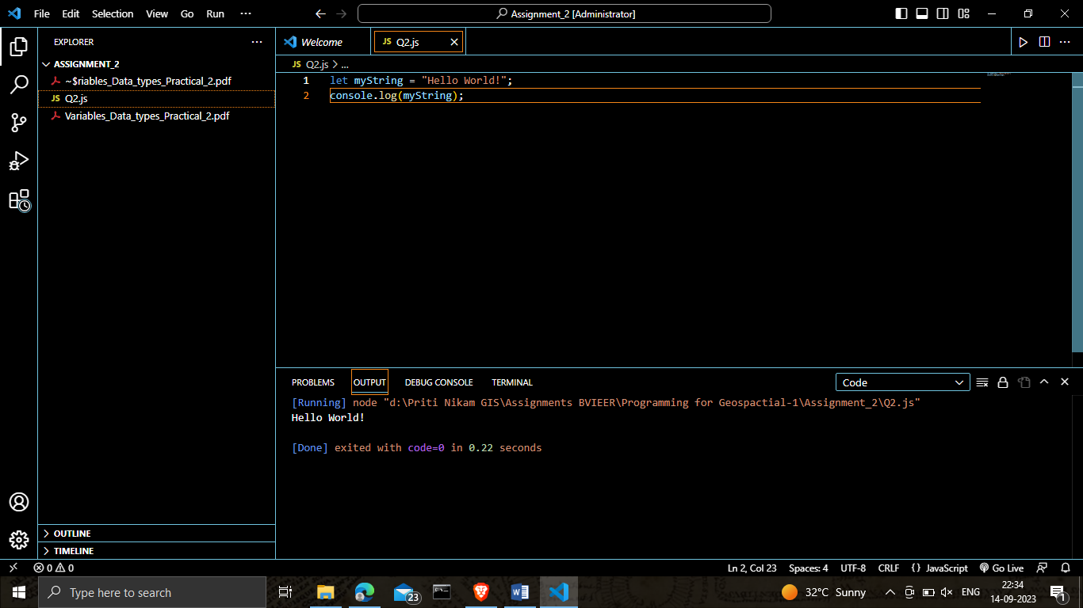

Q3. Create a JavaScript program to create variables of different types (Numeric, String, Boolean) and print the type of each variable.

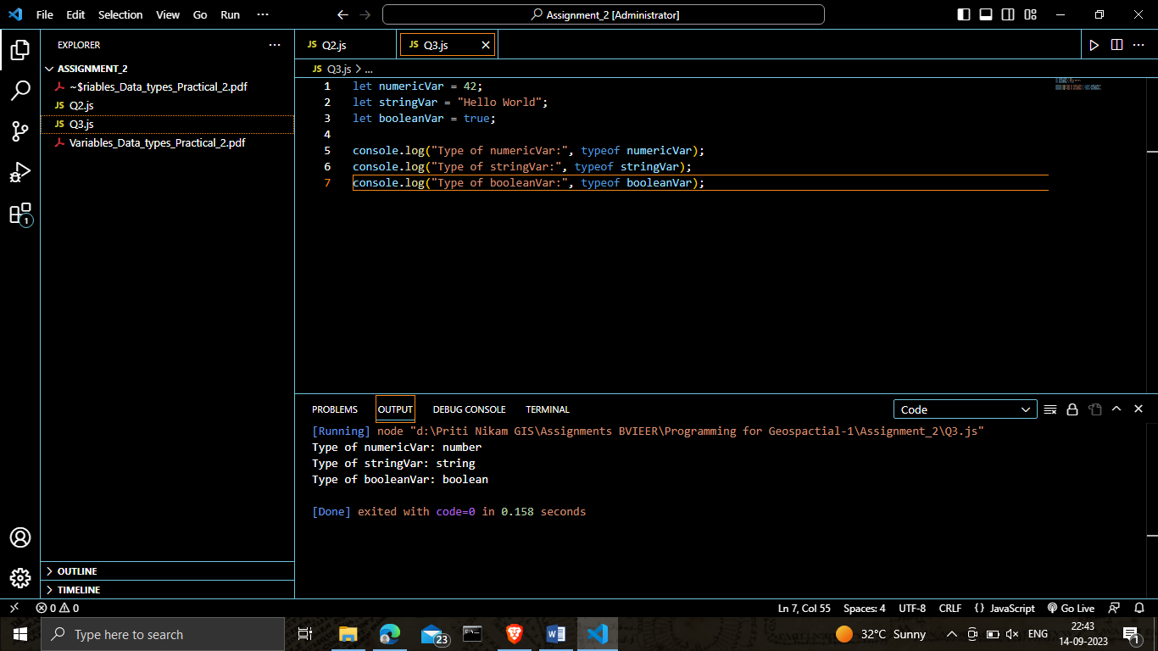

Q4. The radius of the circle is 20cm, use JavaScript to find the area of the circle.

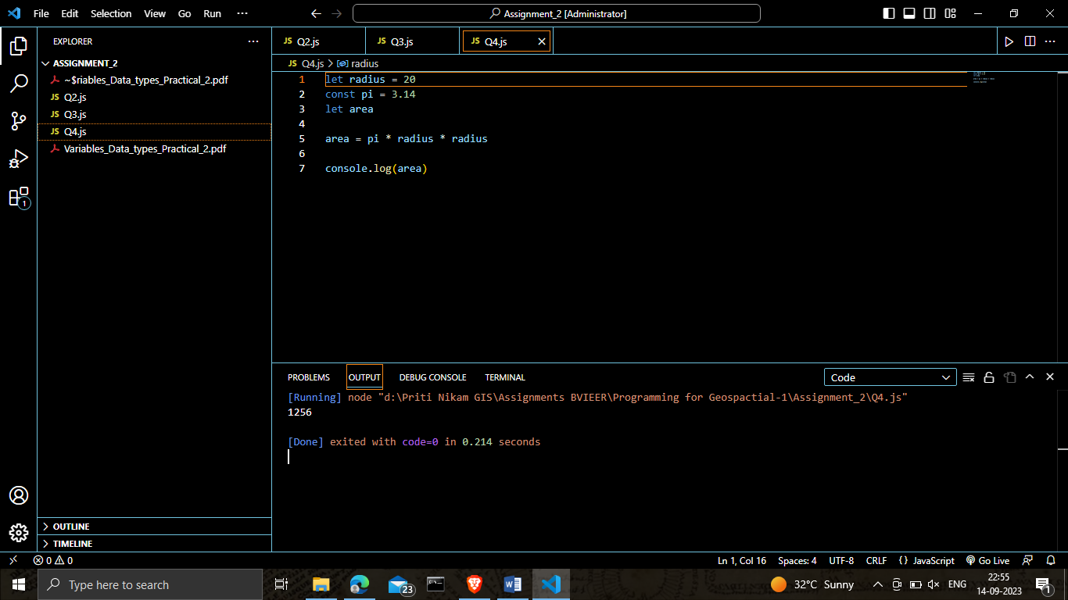

Q5. Create a JavaScript program to concatenate two string variables and print it.

